Customer Portal - comments

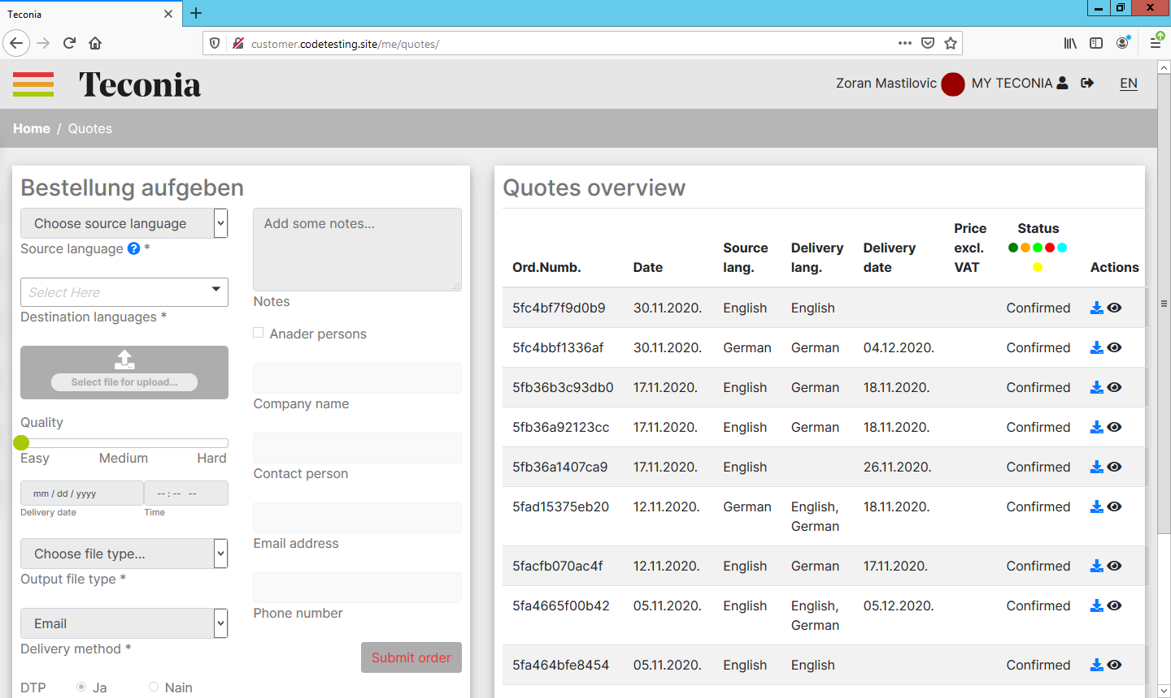 | - There are no languages in the options (except EN and DE)  - In File Typ are needed more options for designs and typ of that.  - In customer mode we cant upload and download files.  - The alignment in the tables in the buttom line is not fine.

